**How scientists are fighting the coronavirus outbreak**

*Nature* senior biology reporter Heidi Ledford describes how researchers including epidemiologists, geneticists and virologists are mobilizing in response to the escalating outbreak.

**Pangolins claimed as outbreak source**

Two researchers at the South China Agricultural University in Guangzhou have suggested that pangolins — long-snouted mammals often used in traditional Chinese medicine — are the [probable animal source of the coronavirus outbreak](https://www.nature.com/articles/d41586-020-00364-2).

Shen Yongyi and Xiao Lihua reported at press conference on 7 February that they had identified the pangolin as the potential source of the virus, named nCoV-2019, based on a genetic comparison of coronaviruses taken from the animals and from humans infected in the outbreak.

The identity of the animal source of nCoV-2019 has been one of the key questions that researchers have been trying to answer. Scientists have already suggested that nCoV-2019 originally came from bats, on the basis of the similarity of its genetic sequence to those of other known coronaviruses, but the virus was probably transmitted to humans by another animal.

Researchers say that the suggestion that pangolins spread the coronavirus to people seems plausible — but caution that the researchers’ work is yet to be published.

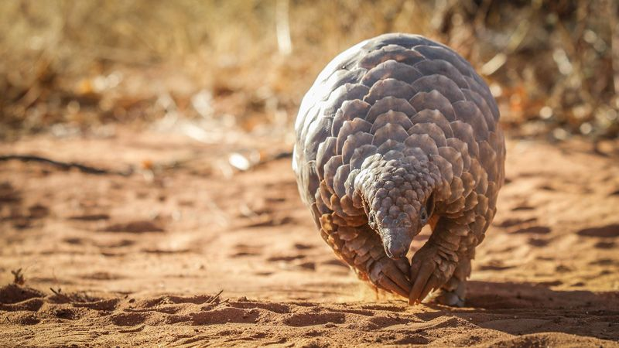

Pangolins are scaly mammals often used in traditional Chinese medicine.Credit: Getty